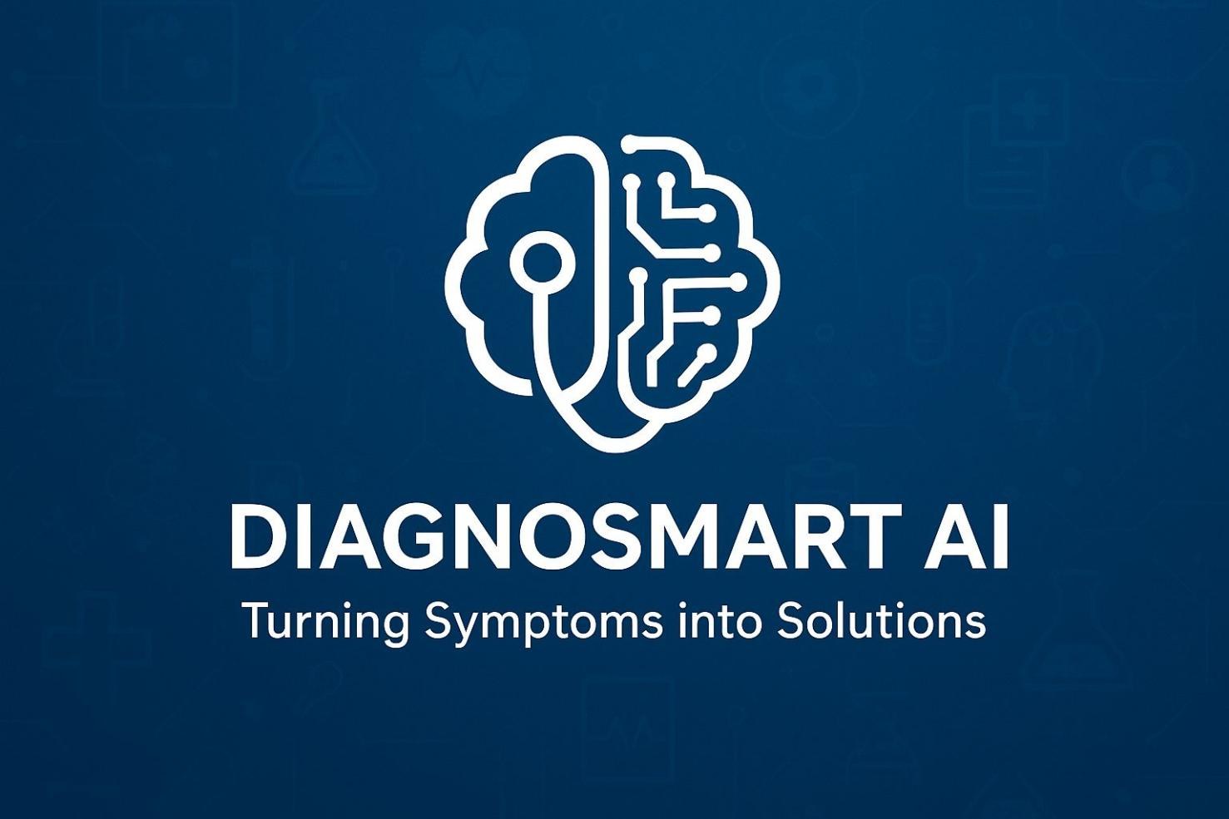

**Background**

Access to health care in multiple communities is challenged today by long waiting times in clinics, short time for health workers to decide on one or more of the multitude of possible diagnoses, and an inability to accurately make a timely diagnosis. Health workers experience pressure to deal with patients quickly, and patients often experience difficulty articulating their symptoms, both of which can result in misdiagnosis and delayed diagnosis. Artificial Intelligence (AI) can help to mitigate all of those challenges as the Fourth Industrial Revolution (4IR) unfolds. AI can improve clinical decision-making by providing real-time diagnostic advice, enabling more efficient triage of patients, and enhancing quality of care. DiagnoSmart is developed as an AI-based, clinic-centered innovative product that uses patient symptom and clinical data to assist healthcare professionals in forecasting potential conditions and directing patients to the correct department. By doing so, it reduces misdiagnosis, enhances efficiency of the consultation process, and improves accessibility of healthcare delivery in a low resource case.

**Theme**

This project's theme is “An AI Solution for Industries – Healthcare.” DiagnoSmart demonstrates the theme by using artificial intelligence to enhance clinical decision-making and healthcare delivery in under-resourced clinics. The solution applies Machine Learning and Natural Language Processing (NLP) to:

* Evaluate patient symptoms and clinical information
* Identify potential conditions based on observed patterns
* Provide the correct department or level of care
* Assist health workers with preventive recommendations and real-time diagnostic information

In this case, DiagnoSmart showcases how artificial intelligence can revolutionize the healthcare industry by minimizing inefficiencies, augmenting diagnostic accuracy, and enabling clinicians to deliver quicker and more reliable care to communities in need.

**Problem Statement**

In communities with developing and limited resources, delivering healthcare services is difficult owing to several challenges that limit efficient and timely care to patients. Overcrowded clinics, limited diagnostic availability, and time constraints in consultations often result in missed and delayed diagnoses. While some challenges are apparent, such as extensive waiting lines and staff coverage shortages, others, such as inconsistent symptom review and lack of decision support, are not as easy to recognize but also complicit. Together, these barriers inhibit healthcare workers from providing trustworthy and precise care to patients in need.

**Visible Problems**

* **Long queues and waiting times**: Patients spend hours at clinics due to inefficient triage and limited diagnostic support, delaying treatment.
* **Limited consultation time**: Healthcare workers often rush through assessments because of patient overload, increasing the risk of misdiagnosis.
* **Miscommunication of symptoms**: Patients may struggle to explain their symptoms clearly, making it harder for clinicians to reach accurate conclusions.
* **Diagnostic inefficiencies**: Without intelligent support, clinicians may rely on manual judgment alone, leading to inconsistent or delayed diagnoses.
* **Geographical barriers**: Remote clinics face staff shortages and lack of diagnostic tools, making it difficult to deliver timely, reliable care.

**Overlooked / Unique Problems**

**Information overload or lack of clarity**: Clinicians often see patients who are confused after they Google symptoms and ultimately this creates miscommunication and anxiety.

**Gaps in health literacy:** Many patients do not understand medical terms or instructions; this makes it more challenging for health care work to follow-up and provide effective care.

**Silent symptoms and preventive care neglect:** Minor symptoms are often ignored until they develop into serious conditions, leading to late-stage diagnoses.

**Inequity in access:** Low income and disadvantaged groups will wait longer and have fewer management facilities compared to higher income communities.

**Challenges regarding medication:** Clinics may be challenged with short stock in medications, which would delay treatment and requiring alternative care plans.

**Lack of personalized guidance:** Health care professionals have limited time; they cannot provide individual lifestyle recommendations that is beneficial for health and prevent future illness.

**Emotional stress:** Long queues, repeated visits, and uncertainty cause anxiety and frustration, which further affect patient well-being.

**Unnecessary clinic visits:** Patients often visit clinics for minor issues that could be managed at home with proper advice, wasting both patient and clinic resources.

**Care fragmentation:** Health care professionals do not have either a system or a unified tool with a consolidated patient profile history, advice and follow-up care in mind.

**Why This Matters**

A timely, accurate, and efficient healthcare service is vital to the health of a community. If we continue to ignore both obvious and non-obvious problems, clinics will continue to suffer inefficiencies, affect meaningful patient interaction while staff become overwhelmed, diagnostics are delayed, and ultimately the health of the population worsens. DiagnoSmart addresses this problem by building a clinic level, decision-support application powered by advanced artificial intelligence (AI), to help improve not only staff resources but also ultimately patient engagement and care quality through timely and personalized responses.

**Solution**

DiagnoSmart is an AI-driven healthcare solution that intends to change the way clinics provide medical advice and support. DiagnoSmart empowers healthcare workers with a structured, intelligent tool to manage care for patients by combining machine learning, natural language processing, and real-time decision support. Clinicians will be able to enter patient complaints and vitals by either text or voice, and then the application will:

* Analyse symptoms and suggest possible conditions or illness.
* Indicate the appropriate healthcare department or lever of care.
* Establish a level of urgency (i.e., routine consult or emergency).
* Offer preventative care lifestyle advice and personalized health planning for secondary care.

Within the Fourth Industrial Revolution (4IR), DiagnoSmart indicates how AI can automate clinical decision supports, thus minimizing limited human resources. How it can personalize care by providing recommendations based on patient data, be more efficient by minimizing triage and reducing consultation overload, and strengthen healthcare delivery in underserved communities through smart technology that can scale.

As AI will more naturally embed into clinical workflows, DiagnoSmart enables healthcare workers to delivery quicker, accurate care - bridging the technology of advanced machine learning with commonplace health issues.

**Main Objective of DiagnoSmart**

The main objective of DiagnoSmart is to improve access to accurate, affordable, and timely healthcare support by leveraging Artificial Intelligence within the Fourth Industrial Revolution (4IR). Specifically, the solution aims to:

* Provide healthcare workers with instant AI analysis of a person's symptoms and vitals.
* Provide patients the appropriate department or level of care to address and/or reduce misdiagnosis of care.
* Deliver personal and preventative health advice in order to support patients towards long-term well-being.
* Reduce waiting times and potential consultation logjams to mitigate burden on clinics.

In doing so, DiagnoSmart serves as a clinical assistant to empower healthcare workers at the front line and improving service delivery, especially for environments strained by the resource limitations.

**Machine learning approach**

DiagnoSmart integrates classification methods, NLP, and algorithms for predicting urgency to enable accurate clinical support. Naïve Bayes and Random Forest classify a list of symptoms into possible conditions. TF-IDF and SVM or Logistic Regression interpret the symptom descriptions. Decision Trees or Gradient Boosting evaluates the urgency of patients for potential triage. Continuous feedback loops ensure the system learns from real clinic data for more reliable and accurate results through its ongoing use.

**Data**

DiagnoSmart employs both structured and unstructured health-related data that directly relates to clinical diagnosis.

**Structured health data**: mappings from symptoms to disease(s), urgency level(s), vitals, and demographic information.

**Unstructured health data:** symptom descriptions attributed by the clinician via text or voice. This information integrates with additional data such as guidelines for preventative care and feedback from healthcare workers to improve usability and prediction.

**Model**

The AI model for DiagnoSmart will be evaluated for accuracy using standard machine learning metrics and healthcare-specific validation methods. For symptom-to-condition prediction, performance will be measured with accuracy, precision, recall, and F1-score to ensure correct and balanced classifications. For urgency prediction, confusion matrices to assess triage accuracy, this ensures the model is both technically sound and practical for clinical use.

**Time Series Analysis on Data**

For DiagnoSmart, time series analysis will be applied to track and predict trends in healthcare demand and symptom patterns over time. By analysing historical patient input data, seasonal illness trends, the system can anticipate spikes in certain conditions (e.g., flu season) and adjust recommendations or healthcare workers. Techniques such as moving averages, exponential smoothing, and ARIMA models will be used to anticipate seasonal spikes. This analysis ensures that DiagnoSmart not only responds to individual patient symptoms but also provides proactive, data-driven insights to improve resource planning and service delivery in real-time. Clinics can use these insights to plan resources and adjust triage protocols proactively.

**Solution Techniques**

DiagnoSmart uses a combination of classification, Natural Language Processing (NLP), and clinical recommendation strategies to assist healthcare workers with accurate symptom analysis and diagnostic guidance. The updated accuracy is achieved through feedback loops, through real-time clinical input, and by retraining on new datasets. Some of the strategies employed to ensure that predictions are accurate, relevant, and reflect changing patient and clinical needs involve ensemble learning, hyperactive parameter searches, and incremental learning.

**Natural Language Processing (NLP)**

DiagnoSmart employs NLP to interpret symptom descriptions entered by health care workers as simple text, extract critical medical terms, and map those terms to possible diagnoses. This will allow for AI-based diagnostic guidance that is relevant, user friendly, and fits the vision of the Fourth Industrial Revolution (4IR)—enabling enhanced real-time clinical decision-making in settings with fewer resources.

**Deep learning**

DiagnoSmart employs Deep Learning methodologies, which involve utilizing neural networks, to interpret complex patterns of symptoms while incorporating voice or text input from the provider. These applications include voice recognition for clinical documentation, natural language understanding of symptom descriptions, and predictive classification of symptoms to enhance the diagnostic process. The utilization of these techniques improves the capability of the system to learn from actual clinical data with subsequent improvement over time, such that diagnostic support becomes smarter, more accurate and responsive to the changing landscape of healthcare.

**Other chatbot/softbot**

DiagnoSmart features a chatbot/softbot that communicates with health care workers via text or voice, facilitating structured symptom reporting, suggesting conditions, and providing clinical decision support. This feature increases efficiency in the consultation process by giving health care workers an intuitive interface they can use to enter patient data and receive AI insights into diagnosis. Using this technology it helped to decrease the cognitive load, facilitate consistent triage, and support clinicians to provide more efficient and accurate care, especially in high-volume or under-resourced clinics.